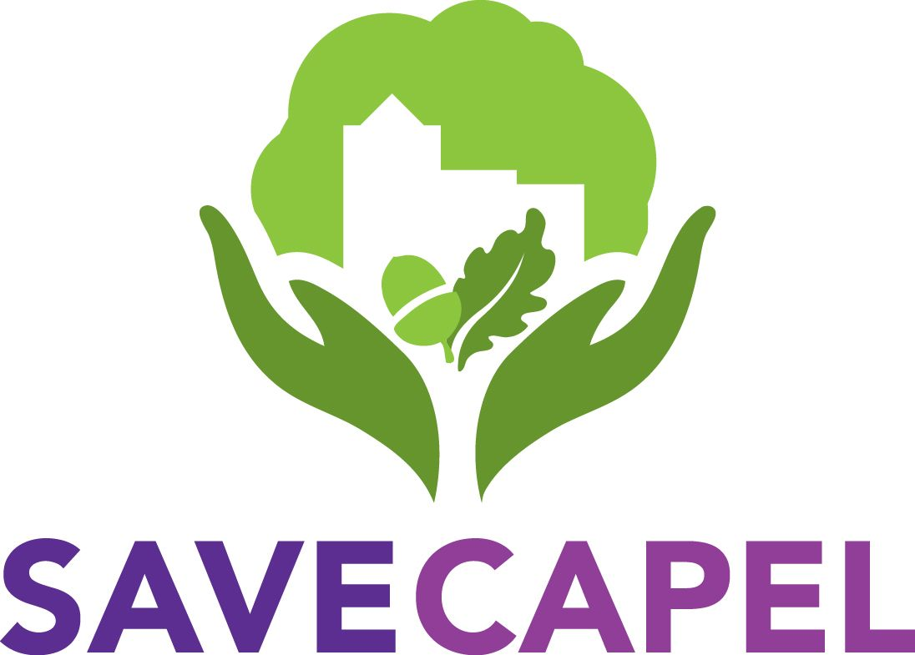
Capel Greenbelt
Protection Society

Save Capel Funding Pledge Scheme

The Save Capel scheme applies to those who wish to pledge any amount of £500 or more, is managed by the Save Capel Executive in accordance with our Privacy Policy , and operates as follows:-

- You advise Save Capel, in confidence, the amount you would like to pledge by completing this form.

- To secure a pledge, an immediate contribution of 20% of the sum pledged should be paid as a donation (see below) and this will be deducted from your pledge balance. Funds are needed now, and we can only commit to paying for our obligations, under charity rules, from funds received.

- At this stage no further money is physically transferred but all the pledges will be recorded, in confidence, in the Save Capel funding plan.
- If/when the time comes that we need additional funding beyond that raised more conventionally, the same percentage of each pledge from all participants of the scheme will be requested. A two-week notice period would be given in writing indicating the amount being requested. Donations made will be deducted from your pledge balance.

- If exceptional circumstances arise which jeopardise your commitment to this scheme, we respectfully request you to advise Save Capel at the earliest convenience.

Donations and Gift Aid
All donations are made to Capel Greenbelt Protection Society (CGPS) who manage the funds on our behalf and can be made by banking app or debit/credit card via our donation page.
If you are an individual taxpayer you can add gift aid on both payment methods which adds 25% to our funds. This applies when all donations are received (not pledges). In addition, you can also claim tax relief on the sum donated. For example, if you are a higher rate taxpayer the net cost to you for a £1,000 donation is £750 and Save Capel gets £1,250. If you have any questions please contact your financial advisor or email us at fundraisingandevents@savecapel.com.
CGPS is a Charitable Incorporated Organisation and is registered with the Charity Commission – Charity Registration #: 1192171 – and a Member of the London Green Belt Council.
The system is set up with the utmost discretion and confidentiality.

The Pledge

I/We the undersigned hereby pledge the sum of money detailed below, as a financial contribution towards the ongoing costs associated with the representations to be made by Counsel on behalf of Save Capel at the Government Inspector hearings and any further legal stages necessary through the course of 2022. This pledge will expire on 31 December 2022. It is made without condition and in the name of Save Capel for the purpose of protecting the green belt in Capel.

Name of donor/donors :

Contact email :

Address :

Phone :

Total pledge amount (£500 minimum) :

Confirmation of 20% initial payment amount (£) :

Signed :

Date :

[OFFICE USE]
Deposit confirmed by: Method:

Please return this form completed and signed either by email to savecapel@gmail.com or by post to Save Capel, ℅ CGPS, 3 Bank Farm Cottages, Sherenden Road, Tudeley, Tonbridge, Kent TN11 0PB

Payments can be made via Wonderful or Kindlink at our donation page or by personal cheque along with this form. If paying by cheque please request a Gift Aid form.

